DAY-14(2/7/2025)
Emp ID : 110714877
NAME :Kinnera venkatamma

Task 1: Create a custom node , add elements to it and traverse it..

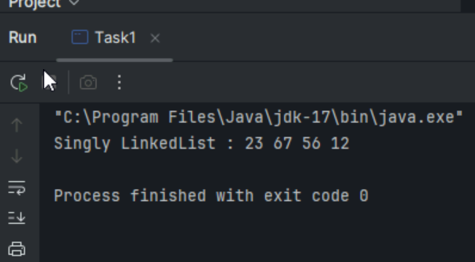

Task 2 .What do you understand by traversing elements in a linked list.

Traversing a linked list means systematically visiting each node in the list, typically from the beginning to the end, to perform some operation on the data stored within each node. This operation could be anything from printing the data to searching for a specific value or modifying the data.

Task 3: Create a Circular Linked list using Task 1 Singly linked list.

class Node {

int value;
Node nextNode;

public Node(int value) {
this.value = value;
}
}

public class CircularLinkedList {
// if the list is empty
private Node head = null;
private Node tail = null;

// …..
}

public void addNode(int value) {
Node newNode = new Node(value);

if (head == null) {
head = newNode;
} else {
tail.nextNode = newNode;
}

tail = newNode;
tail.nextNode = head;
}

private CircularLinkedList createCircularLinkedList() {
CircularLinkedList cll = new CircularLinkedList();

cll.addNode(13);
cll.addNode(7);
cll.addNode(24);
cll.addNode(1);
cll.addNode(8);
cll.addNode(37);
cll.addNode(46);

return cll;
}
public boolean containsNode(int searchValue) {
Node currentNode = head;

if (head == null) {
return false;
} else {
do {
if (currentNode.value == searchValue) {
return true;
}
currentNode = currentNode.nextNode;
} while (currentNode != head);
return false;
}
}

public void deleteNode(int valueToDelete) {
Node currentNode = head;
if (head == null) { // the list is empty
return;
}
do {
Node nextNode = currentNode.nextNode;
if (nextNode.value == valueToDelete) {
if (tail == head) { // the list has only one single element
head = null;
tail = null;
} else {
currentNode.nextNode = nextNode.nextNode;
if (head == nextNode) { //we're deleting the head
head = head.nextNode;
}
if (tail == nextNode) { //we're deleting the tail
tail = currentNode;
}
}
break;
}
currentNode = nextNode;
} while (currentNode != head);
}

Task 4 : Create a code to implement a stack
import java.util.Stack;
class Ds_Stack_Push {
public static void main(String[] args) {
Stack<String> names= new Stack<>();

names.push("Prasunamba");
names.push("Meher");
names.push(".MK");

System.out.println("Stack of names: " + names);
}
}
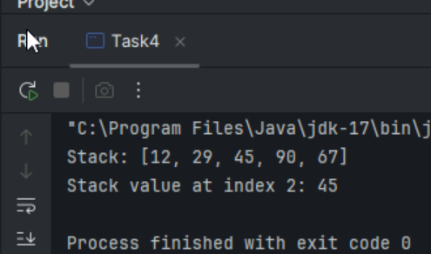
Task 5: Create a stack and pop the element also print the popped element.

import java.util.Stack;
class Ds_Stack_Pop {
public static void main(String[] args) {
Stack<String> names= new Stack<>();

names.push("Prasunamba");
names.push("Meher");
names.push(".MK");

System.out.println("before deletion ");
System.out.println("Stack of names: " + names);

System.out.println("after deletion ");
String dummy = names.pop();

System.out.println("Stack of names: " + names);
System.out.println("deleted element is "+ dummy);
}
}

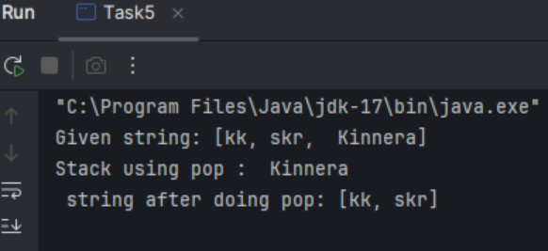

Task 6:

Find an element in the stack and display the position

Hint 👍
Int position = names.search(“value”);

import java.util.Stack;
class Ds_Stack_SearchPosition {
public static void main(String[] args) {
Stack<String> names= new Stack<>();

names.push("Prasunamba");
names.push("Meher");
names.push(".MK");

System.out.println("Stack of names: " + names);

String Val = "Meher";
int position = names.search(Val);

System.out.println("the searched value is at position " + position);
}
}

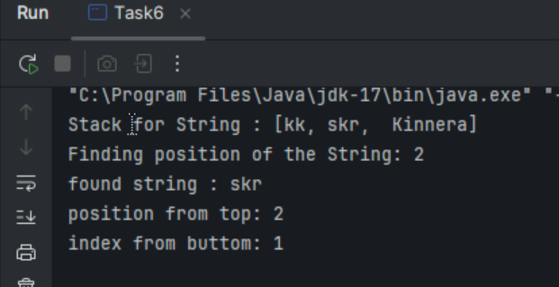

Task 7:

Peek the element and print it ..

import java.util.Stack;
class Ds_Stack_Peek {
public static void main(String[] args) {
Stack<String> names= new Stack<>();

names.push("Prasunamba");
names.push("Meher");
names.push(".MK");

System.out.println("Stack of names: " + names);

String topElement = names.peek();
System.out.println("The top element (without removal); "+ topElement);

System.out.println("Stack of names after peek operation " + names);
}
}

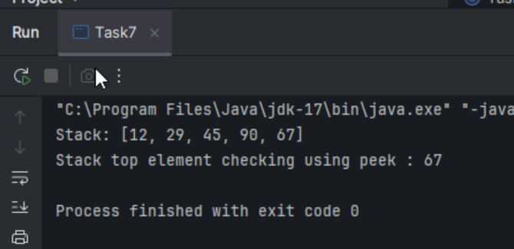

Task 8: Check if the stack is empty or not?

import java.util.Stack;

public class Ds_Stack_Empty {
public static void main(String[] args) {
Stack<String> names = new Stack<>();
System.out.println("Is the stack empty? " + names.empty());

names.push("Prasunamba");
names.push("Meher");

System.out.println("Is the stack empty? " + names.empty());

while (!names.empty()){
System.out.println("Popped: " + names.pop());
}

System.out.println("Is the stack empty? " + names.empty());
}
}

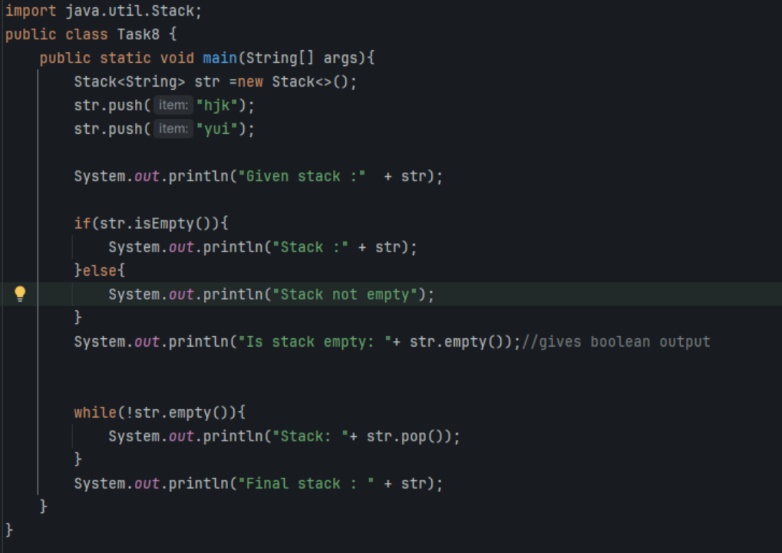

Task 9:What are the methods of the stack class

1.push
2.pop
3.peek/top
4.isEmpty
5.empty
6.search
7.contains
8.size
9.toString

Task 10: What are the common operations in Queues

1.Insert(Enqueue)
2.remove(Dequeue)
3.peek
4.isEmpty
4.size

Task 11: Wap to create a queue with custom methods
Is empty ()
Is full()
Enque
Deque
Peek
display()

public class Queue {
int queueLength = 3;
int items[] = new int[queueLength];
int front = -1;
int back = -1;

void enQueue(int itemValue) {
if(isFull()){
System.out.println("Queue is full");
} else if(front == -1 && back == -1){
front = back = 0;
items[back] = itemValue;
} else{
back++;
items[back] = itemValue;
}
}

void deQueue(){
if(isEmpty()){
System.out.println("Queue is empty. Nothing to dequeue");
} else if (front == back){
front = back = -1;
} else {
front++;
}
}

void display(){
int i;

if(isEmpty()){
System.out.println("Queue is empty");
} else {
for(i = front; i <= back; i++){
System.out.println(items[i]);
}
}
}

boolean isFull(){
if(back == queueLength - 1){
return true;
} else {
return false;
}
}

boolean isEmpty(){
if(front == -1 && back == -1){
return true;
} else {
return false;
}
}
void peek(){
System.out.println("Front value is: " + items[front]);
}
public static void main(String[] args) {
Queue myQueue = new Queue();
myQueue.enQueue(111);
myQueue.enQueue(222);
myQueue.enQueue(777);

myQueue.display();

myQueue.peek();
}

}

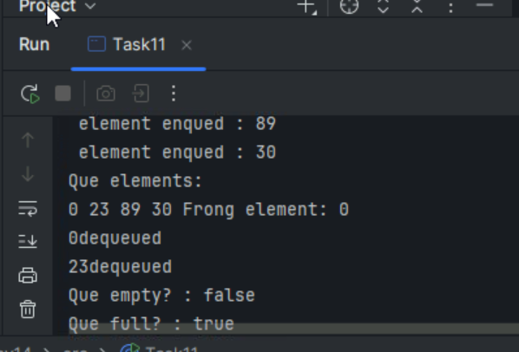

Add ons:

//converting stack and deque into a lists and printing their elements in java using streams.
import java.util.*;
import java.util.stream.Collectors;

class Stack_Deque_to_List.java {
public static void main (String[] args) {

Stack<Integer> stack = new Stack<>();
Deque<Integer> deque = new ArrayDeque<>();

stack.push(1);
deque.push(1);
stack.push(2);
deque.push(2);

List<Integer> list1 = stack.stream().collect(Collectors.toList());
System.out.println("Using Stack: ");
for(int i = 0; i < list1.size(); i++){
System.out.print(list1.get(i) + " " );
}
System.out.println();

List<Integer> list2 = deque.stream().collect(Collectors.toList());
System.out.println("Using Deque: ");
for(int i = 0; i < list2.size(); i++){
System.out.print(list2.get(i) + " " );
}
System.out.println();

}
}

